36.11: a) 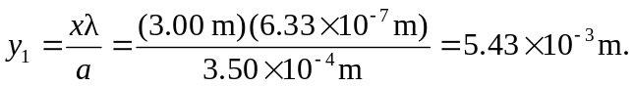 So the width of the brightest fringe is twice this distance to the first minimum, 0.0109 m.
b) The next dark fringe is at 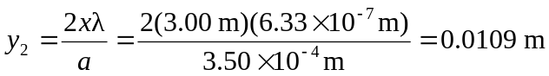.
So the width of the first bright fringe on the side of the central maximum is the distance from 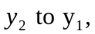 which is 

